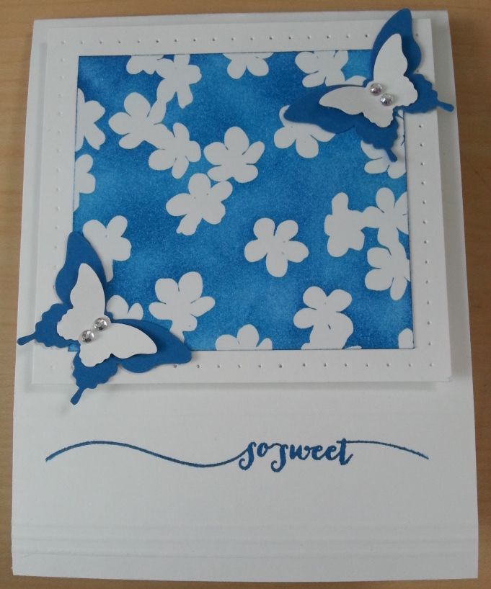
Supplies  Whisper White Card Stock  Pacific Point Card Stock  Irresistibly Yours Designer Series Paper  Pacific Point Ink Pad  Hello Life Stamp Set  Elegant Butterfly Punch  Bitty Butterfly Punch  Essentials Paper Piercing Pack  Paper Piercing Tool  Rhinestone Basic Jewels | Card Measurements  Card Base 4 1/4 X 11  White Layer 3 3/4 X 3 1/2  DSP Layer 3 1/8 X 2 7/8  Essential Supplies  Stampin’ Dimensionals  Snail Adhesive  Simply Scored  Sponge Dauber  Clear Mount Stamp Blocks  Stampin’ Scrub and Stamp Cleaner

Instructions
- Use sponge dauber to apply Pacific Point Ink in a circular motion to Irresistibly Yours Designer Series Paper
- Use Essential Paper Piercing Square Template to pierce boarder around Whisper White Card Stock
- Adhere Irresistibly Yours Designer Series Paper to Whisper White Card Stock with Snail Adhesive
- Score card base upside down at 1/4, 3/8, 1/2, and 1 1/2 using Simply Scored
- Stamp greeting from Hello Life Stamp Set between score lines on front of card base
- Adhere Whisper White Card Stock to card base with Stampin’ Dimensionals
- Punch 2 Elegant Butterflies in Pacific Point Card Stock
- Punch 2 Bitty Butterflies in Whisper White Card Stock
- Adhere Bitty Butterflies to Elegant Butterflies with Snail Adhesive
- Adhere butterflies to Irresistibly Yours Designer Series Paper with Snail Adhesive
- Attach Rhinestone Basic Jewels to butterflies
- Stamp greeting of choice inside card

